|  |
| --- |
| Title: AAS and Digital Twin |

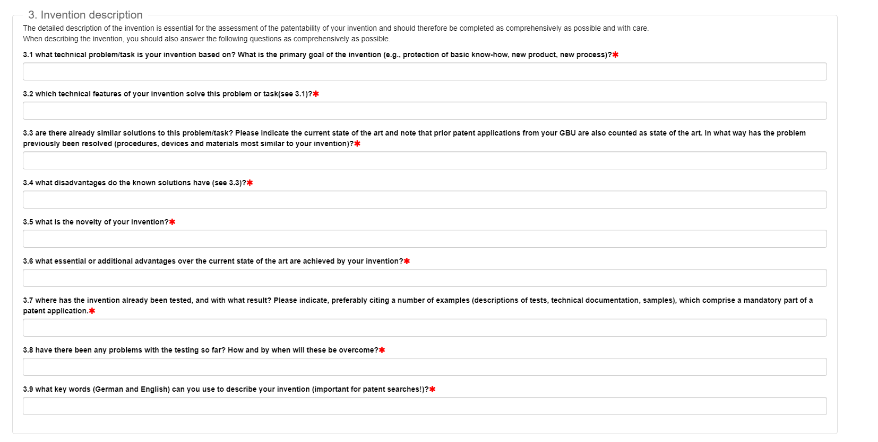

3.1 What technical problem/task is your invention base on? What is the primary goal of the invention (e.g., protection of basic know-how, new product, new process)?

1. Interoperability of Asset Administrative Shell (.aasx) that helps **implementing digital twins for I4.0** that serves as a standardized method of file transfer between different tools that are required for different phases of manufacturing.
2. Asset Administrative Shell (AAS), concept of Industry 4.0 (I4.0) that hepls to achieve industrial automation outlining the advantages of more deeply digitized manufacturing with end-to-end Manufacturer-customer interaction for customization and better product delivery.

Major Technical challenges,

1. Extraction of tool specific data from the Asset Administrative Shell package
2. Creation of Asset Administrative Shell for different kind of Asset corresponding to different process, data value, data-value-type.
3. Logging and versioning the end output of each process generated by tools used in different phases of manufacturing and storing them in standardised schema of Submode and SubmodelElements defined by IDTA.
4. Updating the real-time, timeseries data produced by the machinery of Industry into the AAS Package

3.2 Which technical features of your invention solve this problem or task?

Asset Administration Shell package (.aasx) could be a standard for file transfer between different tools that are required for different phases of manufacturing can be achieved by

programmatical generation of Asset Administrative Shell that helps to create a digital twin of a physical asset that is according to the description of RAMI 4.0 model along with support of AAS-server and Realtime database.It majorly helps in AAS creation and versioning of Asset Administrative shell that can be integrated with other tools where the final outcome will be a Asset Administrative Shell Package (.aasx based file).

End-to-End Manufacturer-customer interaction is achieved with the implementation of OPC-UA PubSub over MQTT, where the machine or the sensors are the Publisher of the data which are feed directly into the AAS Package that can be received by the Subscriber(Client) in Real-Time. Any Update made to the design or requirement by the end customer will be updated universally over the Manufacturers end and new line of product can be produced according to the need.

3.3 Are there already similar solutions to this problem or task? Please indicate the current state of the art and note that prior art and note that prior patent application from your GBU is also counted as the art. In what way has the problem previously been resolved (procedure, devices, and materials most similar to your invention)?

Search for similar patents / Reference papers etc.

3.4 What disadvantages do the known solutions have?

Gaps in the identified State of the Art

**ADD Your idea in details with all the Flow diagram and block diagram explaining the technical details**

3.5 What is the novelty of your invention?

Explain briefly your idea and how do you overcome identified technical disadvantages mentioned previously

3.6 What essential or additional advantages over the current state of the art are archived by your invention?

Advantages or the benefits of your idea

3.7 Where has the invention already tested, and with what results? Please indicate, preferably citing a number of examples (descriptions of test, technical documentations, samples), which comprise a mandatory part of patent application.

3.8 Have there been any problems with the testing so far? How and by when will these be overcome?

3.9 What keywords (German and English) can you use to describe your invention (important for patent search)?

5.1 What application will this invention be used for? Which customer benefit occurs?

5.2 Have information, publications, deliveries or notifications been forwarded to third parties or is any of the above planned? Was an NDA completed beforehand

5.3 Other remarks or explanation regarding the invention

5.4 Please indicate the USP (Unique Selling Proposition) of your invention

5.5 Describe your invention using a maximum of three sentences, such that it can be understood by anyone.